Sangster PTA Agenda October 8th Called to order @ 7:04pm Attendance: 52
Principal Update: Ms. Jankovich/Ms. Redford
No Sangster Students returning to school in Phase 1-4. Ms Jankovich will confirm choices for in-person or virtual before students come back to the building.
Future Material Pick-up tentatively the first week of November
No Student log-on Oct 12 (Holiday, Nov 2(School Planning Day) &3(Election/Teacher Work Day)
October 21st- Library book check out(pick-up)for 5th & 6th Graders
Modified yearbook in the works through LifeTouch
AAP- November 5th referral forms and questions grades 2-7. December 1st deadline for level 4 application. No COGNAT test this year. NNAT will be given in December.
Clinical Team: Ms. Wilkerson/Ms. Railin
Slides available for viewing at https://sites.google.com/view/sangster-es-counselors
Minutes Review: Karen Horvath Approved by 28 votes
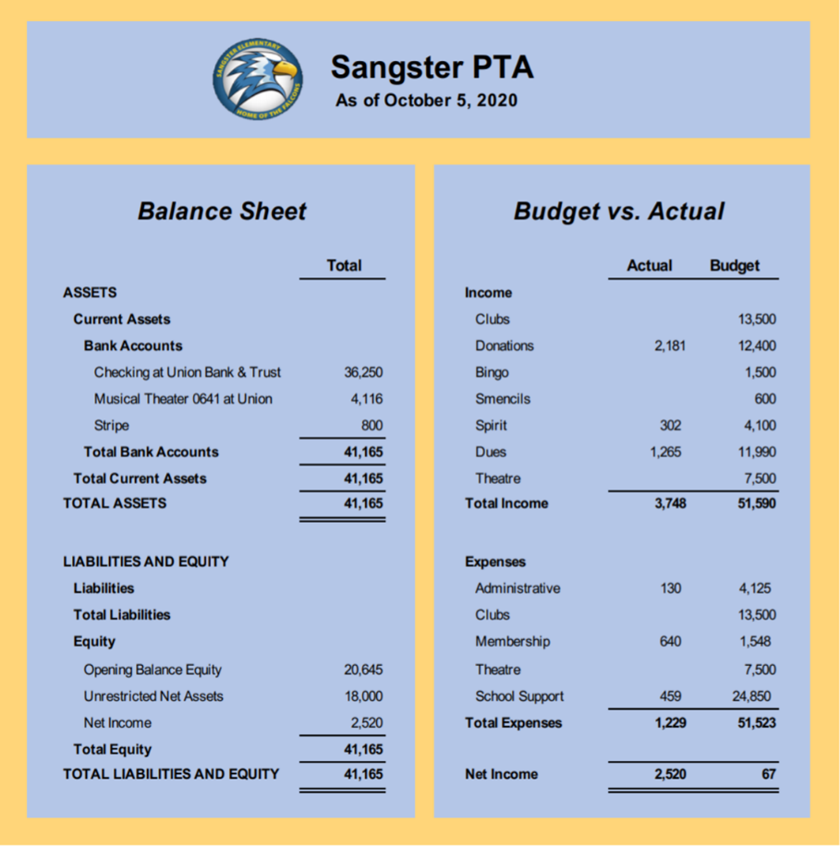
Treasurer Report: Tammy Moffitt

Committee Reports: Karen Horvath
Principal Selection Panel through the month of October. https://sangster.digitalpto.com/principal-selection-process
Directory/MemberHub: Digital directory coming soon. We need more members to join at the new $35/$45 price point to match last year’s dues. Currently we have 54 PTA Memberships compared to last years 267.
Welcoming committee: continuing support through the PTA website
Fundraising: Spirit Wear – online sales close 10/10. Second round of spirit wear may roll out in November.
Chipotle restaurant night was a success. Oct 20th Restaurant night @ Pizano’s.
Auction. – 10/25 – 11/1 around 150 items will be listed. Hoping to generate $5,000 in funds.
Falcon Mission – new leader needed
Reflections: Cherilyn McCall – due 10/9
FUN Activities and etc.
Photos for Ms. Reddel album due 10/9, “ROCKTOBER”, Halloween Flip Grid by grade? – volunteers needed
CONNECT
“SANGSTER PARENTS” FaceBook page, Sangster PTA link on the Sangster Main page at the bottom and https://sangster.new.memberhub.store/ to join our PTA membership.
PTA will have their own emails that will be sent out separate from News You Choose.
Comments/Questions? Next meeting: Thursday November 12 @ 7pm
Meeting adjourned at 8:11pm

